Name:P.Gayathri
Reg.No:192424324

1.Write a Python program to solve the 8-Puzzle Problem using Artificial Intelligence.

Aim:
To implement a Python program that solves the 8-Puzzle problem by comparing the initial state with the goal state.
Algorithm:
Step 1: Start the program.
Step 2: Define the initial state of the 8-puzzle.
Step 3: Define the goal state.
Step 4: Create an empty queue and insert the initial state into it.
Step 5: Create an empty list to store the visited states.
Step 6: Remove the first state from the queue.
Step 7: Compare the current state with the goal state.
Step 8: If both states are equal, display the solution steps and print "Goal State Reached".
Step 9: Otherwise, locate the blank tile (0).
Step 10: Move the blank tile in all possible directions (Up, Down, Left, and Right).
Step 11: Generate the new puzzle states after each valid move.
Step 12: If a generated state has not been visited, add it to the queue.
Step 13: Repeat Steps 6 to 12 until the goal state is found or the queue becomes empty.
Step 14: Stop the program.

Python Code:

from collections import deque
goal = [[1,2,3],
[8,0,4],
[7,6,5]]
initial = [[2,8,3],
[1,6,4],
[7,0,5]]
queue = deque()
queue.append((initial, []))
visited = []
while queue:
state, path = queue.popleft()
if state == goal:
print("Initial State:")
for row in initial:
print(row)
print()
for i, (move, board) in enumerate(path, 1):
print("Step", i, ":", move)
for row in board:
print(row)
print()
print("Goal State Reached")
break
visited.append(state)

for i in range(3):
for j in range(3):
if state[i][j] == 0:
x, y = i, j
moves = [(-1,0,"Move Up"),
(1,0,"Move Down"),
(0,-1,"Move Left"),
(0,1,"Move Right")]
for dx, dy, name in moves:
nx, ny = x+dx, y+dy
if 0 <= nx < 3 and 0 <= ny < 3:
new = [row[:] for row in state]
new[x][y], new[nx][ny] = new[nx][ny], new[x][y]

if new not in visited:
queue.append((new, path + [(name, new)]))
INPUT:
Initial State:
[2, 8, 3]
[1, 6, 4]
[7, 0, 5]

OUTPUT:
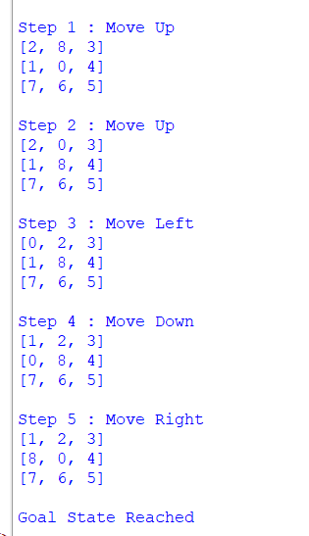

RESULT:
Thus the 8-Puzzle problem is solved successfully.

